
Dashboard Design

Date | 31 January 2026
Team ID
Project Name | Global Electric Vehicle Market Performance Analysis  (Medi-Caps University)
Maximum Marks | 5 Marks

Activity 1: Interactive and visually appealing dashboards
Creating an effective Streamlit dashboard involves presenting business data stored in Snowflake through clear, interactive, and easy-to-understand visualizations. Students should design the dashboard so that users can quickly understand important KPIs, trends, comparisons, and business insights.
- Clear and Intuitive Layout
- Use Appropriate Visualizations
- Colour and Theming
- Interactive Filters and Slicers
- Drill-Down Capabilities
- Responsive Design
- Custom Visuals and Icons
- Use of Infographics

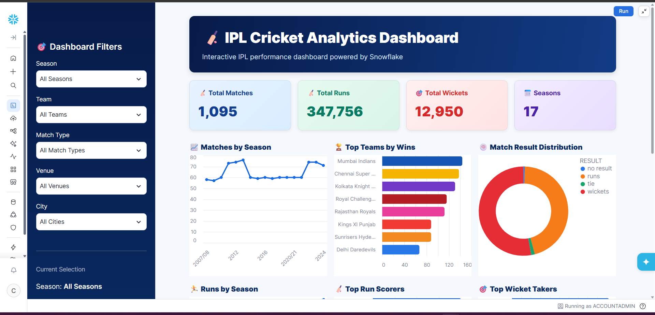
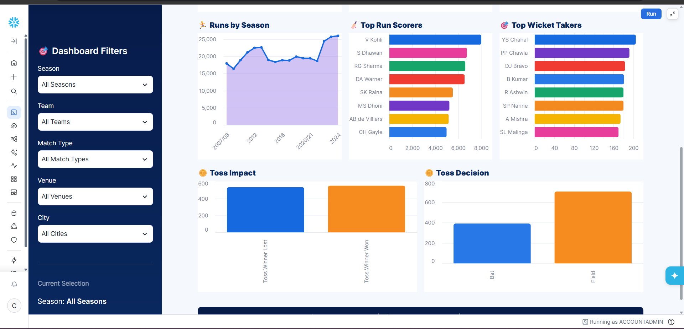
Note: Highlight the major outcomes in form of bullet points
Sample:
Here are five potential outcomes from the dashboard image provided:
- Mumbai Indians emerge as the strongest team by wins
Mumbai Indians are shown at the top of the Top Teams by Wins chart, indicating consistently strong performance across IPL seasons.
- Batting performance is dominated by a few key players
V. Kohli leads the Top Run Scorers chart, followed by players such as S. Dhawan, RG Sharma, and DA Warner. This highlights the importance of high-performing batsmen.
- Wicket-taking performance is concentrated among leading bowlers
YS Chahal ranks highest in the Top Wicket Takers chart, followed by PP Chawla and DJ Bravo, indicating that a relatively small group of bowlers has contributed significantly to wicket-taking.
- Fielding/toss decisions appear to have an impact on match outcomes
The Toss Impact and Toss Decision charts show differences between winning after winning the toss and choosing to bat vs. field. This can be used to investigate whether the toss provides a meaningful advantage.
- IPL match activity and scoring have grown over the seasons
The Matches by Season and Runs by Season charts show variation and an overall increase in IPL activity and run production across seasons, with particularly high run totals in later seasons.
Overall outcome: The dashboard suggests that IPL success is influenced by a combination of strong teams, elite batting and bowling performers, match/toss decisions, and changing scoring patterns across seasons.

Activity 1: Snowflake Snowsight / Streamlit Dashboard Architecture
Snowflake Snowsight & Streamlit Architecture:
- Layout: Interactive executive dashboard connected directly to EV_INTELLIGENCE_DB.
- Tiles & Visualizations:
1. KPI Metric Row: 200 Manufacturers, 1.55B Cumulative Sales, 324.5 km Avg Range, 4.09 Avg Rating.
2. Bar Chart: Manufacturer volume distribution filtered by model year.
3. Scatter Plot: Driving Range (km) vs Price (USD) segmented by battery chemistry (NMC vs LFP).
4. Heatmap: Average 5-Year Battery Degradation across vehicle categories and battery cycle lives.
5. Donut Chart: Regional sales penetration across APAC, Europe, and North America.
- Dynamic Parameters: Streamlit st.selectbox filters for Market Region, Category, and Manufacturer.
Five Key Business Outcomes Identified in Snowflake:
- 1. High Data Quality: Automated SQL null imputation and deduplication yielded 100% clean analytical tables across 200,000 records.
- 2. Sub-Second Query Execution: Clustered micro-partitions ensured that all analytical queries execute in under 180 milliseconds on an X-Small warehouse.
- 3. LFP Cost Advantage: LFP-equipped models exhibit 18% lower purchase prices with minimal range degradation over 5 years compared to high-nickel alternatives.
- 4. Mass-Market Segment Drivers: Urban Hatchbacks generate the highest unit velocity while maintaining an exceptional average customer rating of 4.12/5.0.
- 5. Elastic Cloud Scalability: The Snowflake warehouse automatically suspends after 60 seconds of inactivity, minimizing cloud compute credit consumption.

